Data Communications and Networking
Lab 1 - Connectivity, VPCs, Subnets, VLANs
_{Calum Murray-Submission}

_{Part 1:}
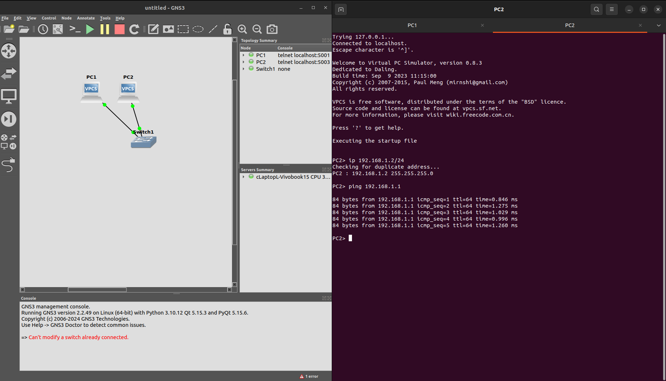

_{Part 2:}
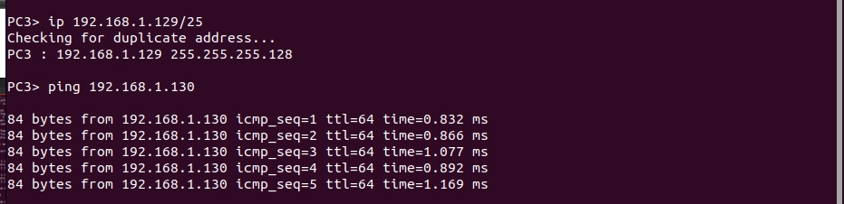
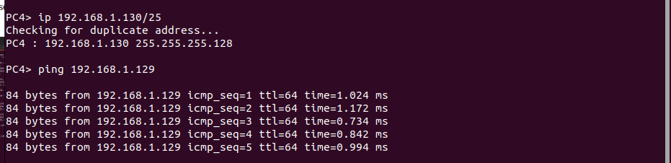
You can’t ping pc3/4 from pc1 because they are on different subnets.
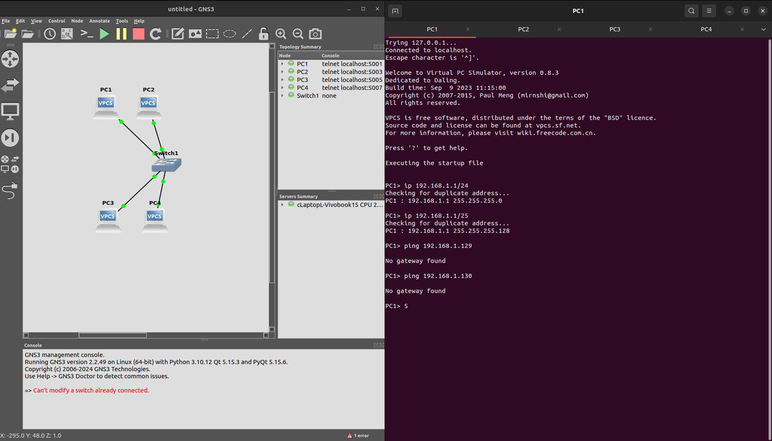

_{Part 3:}
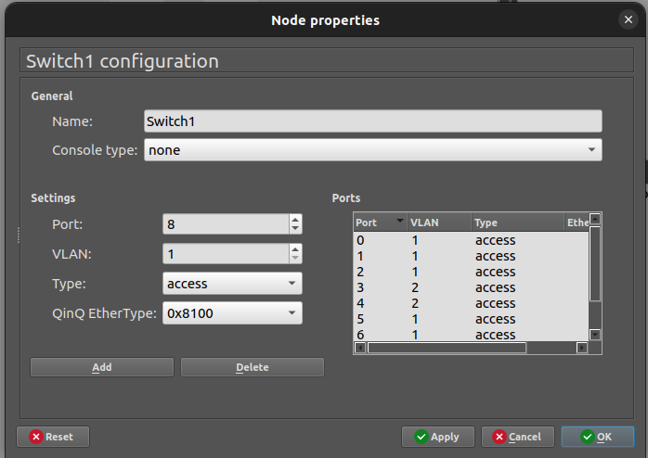

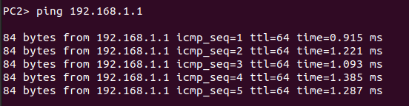
_{Could ping because same VLAN}

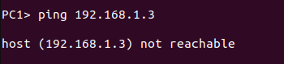
Couldn’t ping because different VLAN
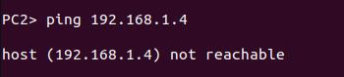
Couldn’t ping because different VLAN
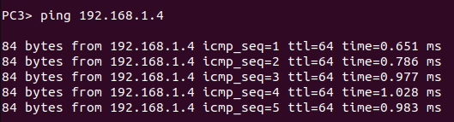
_{Could ping because same VLAN}

_{Part 4:}
ICMP - internet message control protocol

Can’t see ping from pc3 capture, because swicthes send privately to mac address

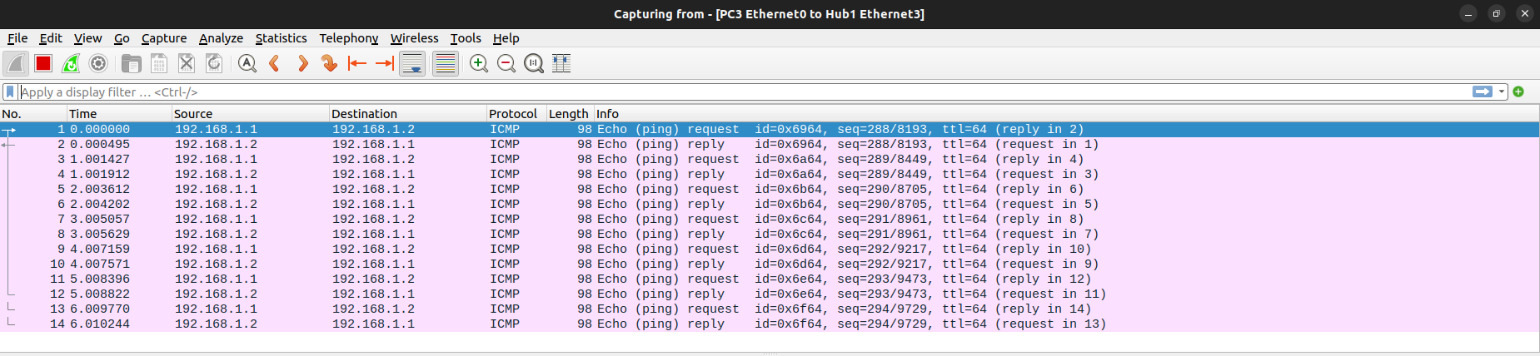
You can see all pings from hubs as they broadcast to each port

